Contact us

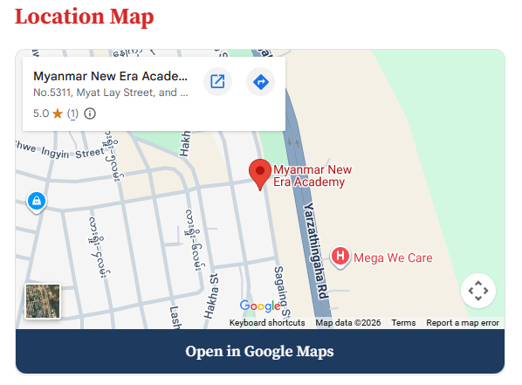 | Get In Touch  We are here to provide educational services.  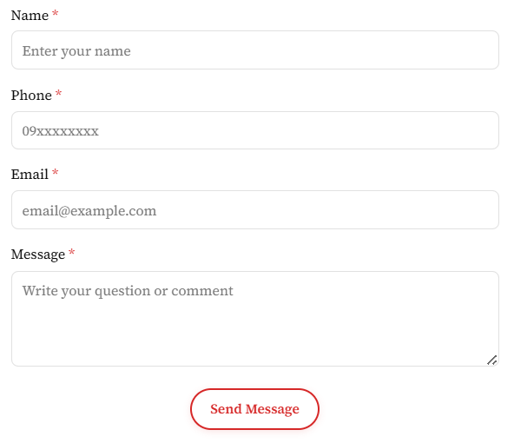
Contact Information
No.5311, Myat Lay Street, and Sagaing St, Ottarathiri 15015, Naypyitaw
+95 9 885 511664, +95 9 885 511665
office@mmnea.com
myanmarneweraacademy@gmail.com

